Abstract— Direction-of-Arrival (DoA) estimation is a key component of RF localization systems; however, performance is highly dependent on array geometry, environmental conditions, and algorithm selection. This research presents a hybrid antenna array system designed to estimate the azimuth, elevation, and range of a moving RF source using subspace-based DoA techniques. The system combines a vertical uniform linear array with either a circular or horizontal linear array configuration and processes received signals using the MUSIC and ESPRIT algorithms. These algorithms are implemented on the FMComms5/Zynq software-defined radio (SDR) platform. System performance was evaluated through Monte Carlo simulations as well as experimental testing with both static and moving RF sources. Results demonstrate that array geometry significantly influences estimation accuracy and snapshot requirements, while both algorithms provide stable DoA estimates under realistic indoor conditions. These findings highlight the practical advantages and limitations of hybrid antenna array configurations for real-time RF localization.
Keywords— Direction-of-Arrival (DoA), Azimuth, Elevation, localization, Uniform Linear Array (ULA), Uniform Circular Array (UCA), Signal to Noise Ratio (SNR), Root Mean Squared Error (RMSE)

INTRODUCTION
In recent years, unmanned aerial vehicles (UAVs) have become more common in commercial, industrial, and defense settings, which has increased interest in practical ways to track and locate them. Small UAVs can be difficult to detect and localize consistently because they may fly low, change direction quickly, and transmit relatively low-power RF signals, while optical sensors like LiDAR typically require the target to be within the sensor’s field of view and can be affected by clutter or multipath. This work presents a real-time RF localization prototype capable of estimating the azimuth, elevation, and range of a single static or moving 2.4 GHz RF source. Angular estimates are obtained using multi-element antenna arrays and subspace-based DoA algorithms, while range is measured using a mechanically steered LiDAR unit. Multiple array configurations, including ULA/UCA and orthogonal ULA/ULA arrangements, are evaluated alongside MUSIC and ESPRIT algorithms under consistent indoor test conditions. Performance is quantified using mean angular error and standard deviation across varying SNR levels and snapshot counts to determine the most accurate and stable configuration for single-source localization.

Project Objectives

The primary objective of this project is to develop a real-time radio frequency (RF) localization system capable of estimating the azimuth, elevation, and range of a single moving RF source. Angular localization (azimuth and elevation) is achieved through direction-of-arrival (DoA) estimation techniques, while range information is obtained using a LiDAR-based distance sensing system. The estimated angular coordinates are used to mechanically steer a pan-and-tilt LiDAR apparatus, enabling full localization in spherical coordinates (φ, θ, r).

To achieve angular estimation, multiple antenna array geometries are investigated, including Uniform Linear Array (ULA) and Uniform Circular Array (UCA) configurations. Hybrid array combinations consisting of ULA/UCA and orthogonal ULA/ULA arrangements are implemented to evaluate suitability for two-dimensional DoA estimation.
In addition to hardware configuration comparisons, multiple subspace-based estimation algorithms are evaluated. These include Multiple Signal Classification (MUSIC) and Estimation of Signal Parameters via Rotational Invariance Techniques (ESPRIT). Performance is assessed under consistent indoor testing conditions using a single 2.4 GHz RF source.
Quantitative evaluation metrics include the mean angular error and standard deviation of azimuth and elevation estimates across Monte Carlo simulations and experimental trials. These metrics are used to determine the most accurate and stable array–algorithm configuration for single-source localization. The overall goal is to identify a system architecture that provides reliable, low-variance angular estimation suitable for real-time implementation.

Project Deliverables

The aim of this project is to deliever a real-time system that preforms DoA estimations for a single RF source. The demonstration displays azimuth and elevation estimates produced from the array processing chain and support end-to-end operation using the competition hardware stack. When integrated, the demonstration also includes LiDAR-based ranging driven by the DoA output to enable full (φ, θ, r) localization within the defined test environment.

Additional deliverables include documented software and hardware support packages to ensure reproducibility of results. These materials consist of MATLAB scripts, CAD drawings, configuration files, experimental datasets, and detailed setup instructions outlining required dependencies. A formal test procedure will be provided to define the experimental configuration, calibration steps, parameter settings, and evaluation metrics, enabling independent replication and validation of system performance. Supporting documentation will be included within this paper or provided as separate appendices for comprehensive analysis.

MATHEMATICAL BACKGROUND
This section develops the mathematical background for the subspace-based direction-of-arrival (DoA) estimation techniques evaluated in this study. Based on narrowband signal modeling, the derivations of the MUSIC and ESPRIT algorithms are presented, emphasizing their subspace decomposition principles and their applicability to the array geometries considered.

Multiple Signal Classification (MUSIC)

The MUSIC method is a widely used high-resolution, subspace-based method widely applied in array signal processing. As illustrated in Fig 1, a far-field source impinging on a uniformly spaced antenna array produces time-shifted and phase-shifted measurements across the sensor elements. These spatial phase differences encode the incident direction of the source. MUSIC exploits the structure of the array covariance matrix to decompose the received data into orthogonal signal and noise subspaces.

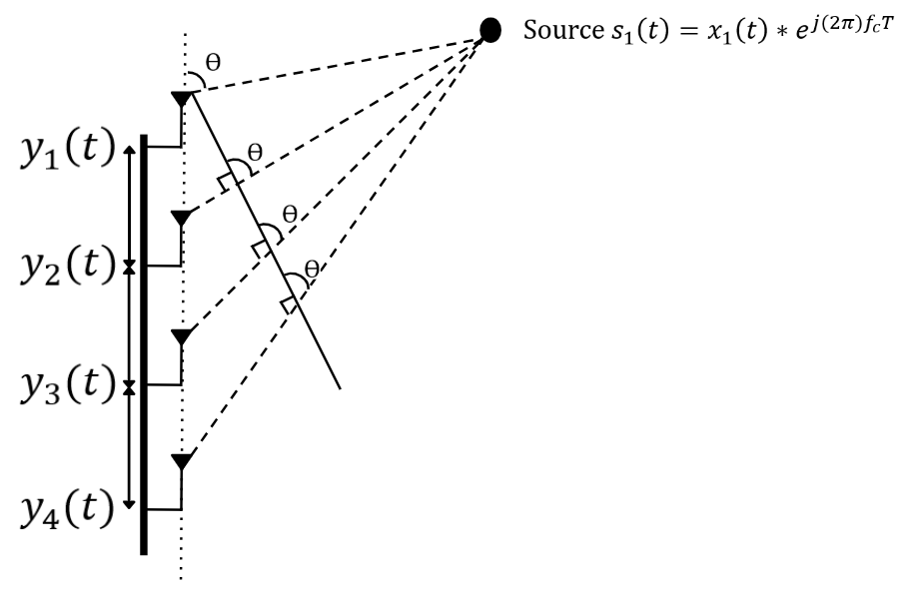
Fig 1. MUSIC DoA Model with Source impinging on ULA

Due to the propagation delay between adjacent antennas, the incident wave produces progressive phase shifts across the array elements that depend on the angle of arrival 𝜃. The received array measurements at time 𝑡 can be expressed as a column vector whose entries correspond to the signals observed at each antenna element. Under the single-source assumption, the array output is modeled as the product of a direction-dependent steering vector and the transmitted signal, corrupted by additive noise. The received signal vector is therefore described as:

$$Recieved Values Steering Vector Noise Vector$$
$$Y\left(t\right) = A(Ө)*s_{1}(t) + N(t)$$
$$\left|\begin{matrix}y_{1}\left(t\right) \\ y_{2}\left(t\right) \\ y_{3}\left(t\right) \\ y_{4}\left(t\right)\end{matrix}\right| = \left|\begin{matrix}1 \\ e^{-jdksinӨ} \\ e^{-j2dksinӨ} \\ e^{-j3dksinӨ}\end{matrix}\right|x_{1}\left(t\right)*e^{j\left(2π\right)f_{c}T} + \left|\begin{matrix}N_{1}\left(t\right) \\ N_{2}\left(t\right) \\ N_{3}\left(t\right) \\ N_{4}\left(t\right)\end{matrix}\right|$$

After collecting 𝑁 time samples (snapshots) of the received vector y(t), the spatial information contained in the inter-element phase differences is captured through the sample covariance matrix. This covariance aggregates the cross-correlations between antenna channels and suppresses uncorrelated noise as the number of snapshots increases. The sample covariance is estimated as:

 | $${\hat{R}}_{x}=\frac{1}{N}\sum_{n=1}^{N}{x\left[n\right]x^{H}[n]}=\frac{1}{N}XX^{H}$$ | (1)

MUSIC exploits the fact that, under the single-source model, ${\hat{R}}_{x}$can be decomposed into a rank-one signal component and noise component. Eigenvalue decomposition separates these contributions by partitioning the eigenvectors into a signal subspace and a noise subspace:

 | ${\hat{R}}_{x}=UΛU^{H}=[\begin{matrix}U_{S} & U_{N}\end{matrix}]\left[\begin{matrix}Λ_{S} & 0 \\ 0 & Λ_{N}\end{matrix}\right]{[\begin{matrix}U_{S} & U_{N}\end{matrix}]}^{H}$ | (2)
A key result is that the true steering vector 𝑎(𝜃) lies in the signal subspace and is therefore orthogonal to the noise subspace. Consequently, when a candidate angle 𝜃 matches the true direction of arrival, the projection of 𝑎(𝜃) onto the noise eigenvector approaches zero. MUSIC converts this orthogonality condition into a pseudospectrum by evaluating the inverse of the steering vector’s projection onto the noise subspace, The DoA estimate is obtained by searching over 𝜃 and selecting the angle corresponding to the peak:

 | $$P_{MUSIC}\left(θ\right)=\frac{1}{a^{H}\left(θ\right)U_{N}{U_{N}}^{H}a\left(θ\right)}$$ | (3)

For a Uniform Circular Array (UCA), the MUSIC algorithm itself remains unchanged; however, the steering vector must be modified to reflect the circular geometry. Unlike the ULA, where phase shifts progress linearly along the array, each UCA element is positioned at a different angular location around a circle of radius 𝑅 As a result, the phase at each element depends on the projection of the incoming wave onto that element’s position.
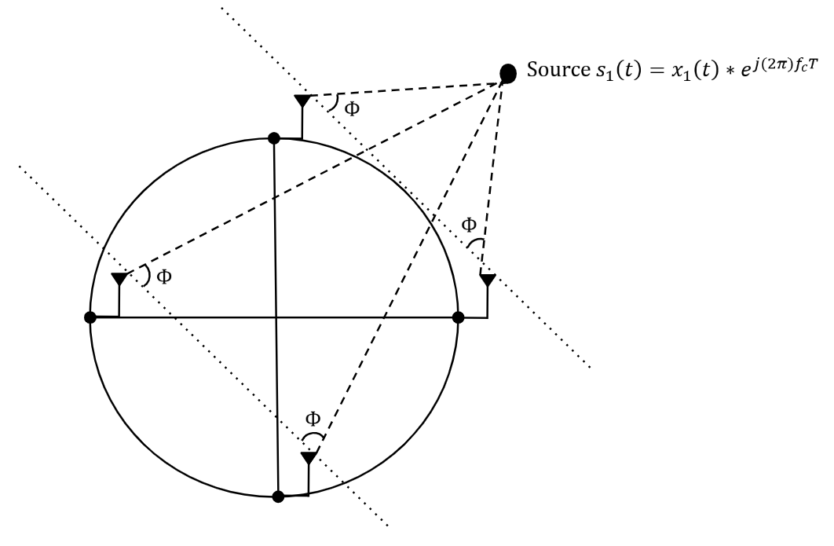
Fig 2. MUSIC DoA Model with Source impinging on UCA

Estimation of Signal Parameters via Rotational Invariance Techniques (ESPRIT)

The Estimation of Signal Parameters via Rotational Invariance Techniques (ESPRIT) is a subspace-based DoA estimation method that exploits the translational symmetry of uniform linear arrays. As shown in Fig. 3, the four-element ULA is partitioned into two overlapping subarrays separated by a known spacing 𝑑. Because the incident wave produces a consistent phase progression across the array, the two subarrays observe signals that differ by a fixed phase rotation related to the angle of arrival 𝜃. ESPRIT leverages rotational invariance within the signal subspace to directly compute the direction of arrival without requiring a spectral search.

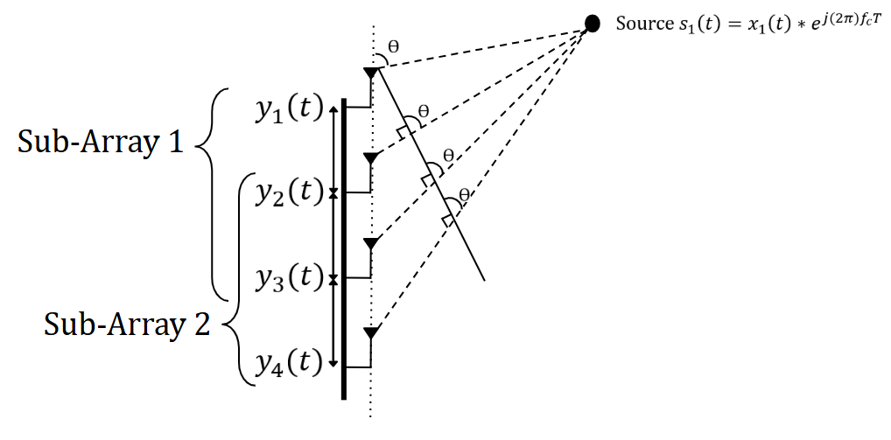
Fig 3. ESPRIT DoA Model with Source impinging on ULA

To exploit this array subspace symmetery, the signal subspace obtained from the covariance matrix $E_{s}$ is multipled by the corresponding shifted arrays, creating the subspaces of Sub-Array 1 & 2, as seen in the equation below. the two subarrays share common elements and are separated by a known spacing 𝑑, the received signals in each subarray differ only by the phase shift induced by the incident plane wave. This relationship helps isolate the phase shift associated with the source DoA.

 | $$E_{1}= J_{1}E_{s} E_{2}= J_{2}E_{s}$$ | (3)
Due to this shift invariance property, the phase difference between the separated signal subspaces contains the term kdsin(θ) where k is the wave number. The eigenvalue associated with the subspace maintains the phase shift information, so the DoA estimation can be extracted from the eigenvalues using Eq. 4 below:

 | $$\hat{θ}= \sin^{-1}(\frac{∆λ}{kd})$$ | (4)

SIMULATIONS
This section evaluates the practical performance of the proposed MUSIC and ESPRIT algorithms as implemented in this work. Monte Carlo simulations are conducted to assess robustness to noise and to model expected real-world performance. Two key parameters are analyzed: Signal-to-Noise Ratio (SNR) and number of snapshots, each evaluated with respect to DoA estimation accuracy. To ensure a fair and direct comparison, both algorithms are tested under identical simulation conditions, including array configuration, source characteristics, and noise realizations.

SNR vs, DoA Accuracy Monte Carlo Trails

The first Monte Carlo simulation evaluates the MUSIC algorithm’s immunity to noise. The elevation estimation using the ULA demonstrates strong robustness, maintaining low RMSE even at relatively low SNR values and converging to near-zero error at moderate to high SNR levels. In contrast, the azimuth estimation using the UCA exhibits a clear threshold behavior, with large estimation errors at low SNR due to poor signal and noise subspace separation. Once the SNR surpasses the threshold region, the azimuth error rapidly decreases and stabilizes. These results illustrate the inherent sensitivity of subspace-based methods to noise and highlight the influence of array geometry on estimation stability.

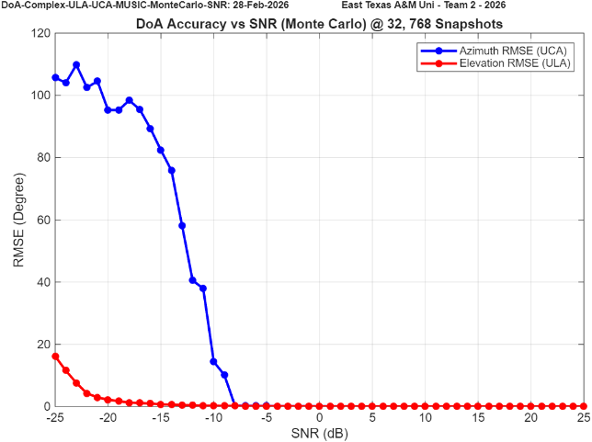
Fig 4. MUSIC ULA/UCA DoA SNR vs. Accuracy Simulation

Although ESPRIT was initially considered for both array configurations, it was not implemented for the ULA/UCA combination. The UCA does not inherently provide the required phase-shift invariance without additional transformations or virtual array mapping. Due to the limited number of elements and lack of directly paired phase-aligned subarrays for the configuration we have.

The second simulation evaluates the ESPRIT algorithm’s immunity to noise using the ULA/ULA configuration. The elevation estimation demonstrates strong robustness across the tested SNR range, maintaining relatively low error at reduced SNR and converging toward near-zero RMSE as SNR increases. Similarly, the azimuth estimation improved compared to the MUSIC simulations, meaning more reliable subspace separation and phase-shift extraction at moderate-to-high SNR values.

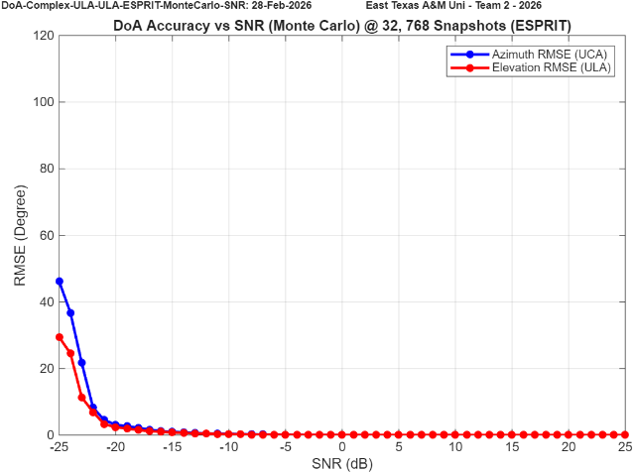
Fig 5. ESPRIT ULA/ULA DoA SNR vs. Accuracy Simulation

The final SNR vs. Accuracy simulation evaluates the MUSIC algorithm for the ULA/ULA configuration. Using the dual-linear array design provides improved SNR resilience, as the uniform linear geometry enhances the shift-invariant structure and stabilizes covariance estimation. As SNR increases, a clear separation between the signal and noise subspaces is observed, resulting in rapid convergence of the DoA estimates and reduced RMSE in both azimuth and elevation. These results demonstrate the robustness of the MUSIC algorithm when both array dimensions satisfy uniform linear structure.

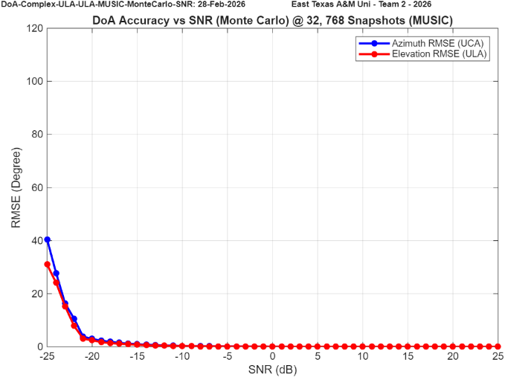
Fig 6. MUSIC ULA/ULA DoA SNR vs. Accuracy Simulation

Number of Snapshots vs. Accuracy

The second set of Monte Carlo simulations evaluates how well the MUSIC and ESPRIT algorithms perform when operating with a limited number of snapshots. Snapshot count directly affects subspace stability, since fewer samples reduce covariance accuracy and increase estimation variance, while larger snapshot sets improve signal and noise subspace separation at the cost of added computational time. This study helps us understand how efficient our algorithms can be in real-time operation without sacrificing estimation accuracy. The results first focus on the MUSIC algorithm under the ULA/UCA configuration to determine the minimum number of snapshots required to maintain stable azimuth and elevation estimates. This configuration stabilizes at around 2¹¹ (2048) snapshots, so anything above that threshold should provide strong results.

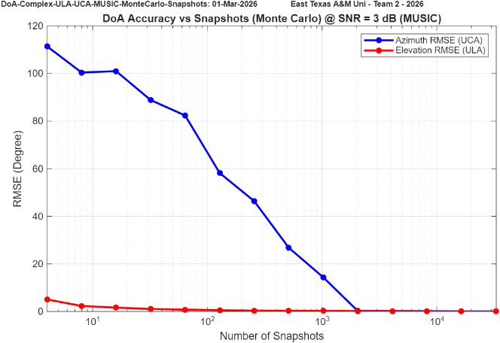
Fig 7. MUSIC ULA/UCA DoA Number of Snapshots vs. Accuracy Simulation

The second set of simulations evaluates the ESPRIT algorithm under the ULA/ULA configuration as the number of snapshots is varied. Unlike the MUSIC results, the ESPRIT implementation shows strong stability even at low snapshot counts, with both azimuth and elevation RMSE remaining near zero across the tested range. These results suggest that ESPRIT offers strong real-time efficiency in the dual-ULA configuration without requiring a large snapshot buffer to preserve estimation accuracy.

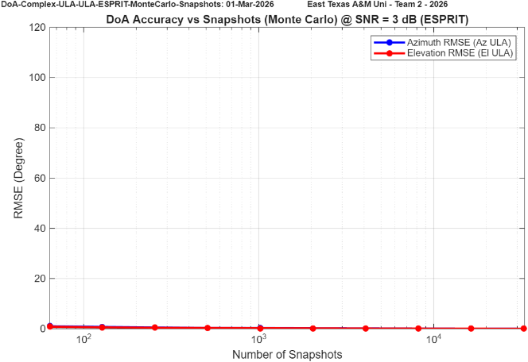
Fig 8. ESPRIT ULA/ULA DoA Number of Snapshots vs. Accuracy Simulation

The final set of results evaluates the MUSIC algorithm under the ULA/ULA configuration as the number of snapshots is varied. In this case, both azimuth and elevation estimation remain highly stable across the tested snapshot range, with RMSE values remaining near zero even at lower snapshot counts. Compared to the earlier ULA/UCA results, the dual-ULA geometry provides improved subspace consistency, resulting in stronger signal and noise space separation. These results suggest that array geometry has a greater impact on the required snapshot count than the choice of subspace algorithm. When the array structure satisfies uniform linear conditions in both dimensions, both MUSIC and ESPRIT maintain stable performance even with reduced covariance averaging.

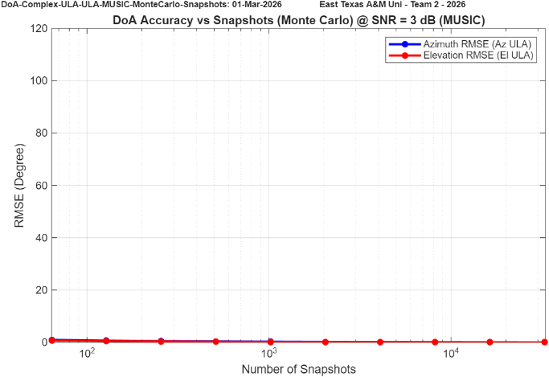
Fig 9. MUSIC ULA/ULA DoA Number of Snapshots vs. Accuracy Simulation

ANTENNA RADIATION PATTERN
An important aspect of evaluating the performance of the antenna array configurations istheir radiation patterns and how it affects the estimations. The radiation pattern describes the sensitivity of the array from every possible signal source direction. In this study, the MATLAB Antenna Toolbox is used to simulate and visualize the radiation characteristics of the array configurations.

UCA
The first radiation pattern examined is the uniform circular array (UCA). Although this array is primarily used for direction-of-arrival estimation in the azimuth plane, it is still important to evaluate the radiation characteristics in both azimuth and elevation. The overall radiation response determines the sensitivity of the array to signals arriving from different spatial directions. The dimensions of the UCA included in this project is one with a radius of 0.5λ (62.5mm) and a chord spacing of 0.707λ (88.4mm). These dimensions were chosen to avoid grating lobes, and to mitigate mutual coupling between elements. Fig 10. presents the geometry of the UCA within MATLAB Antenna Array Designer.

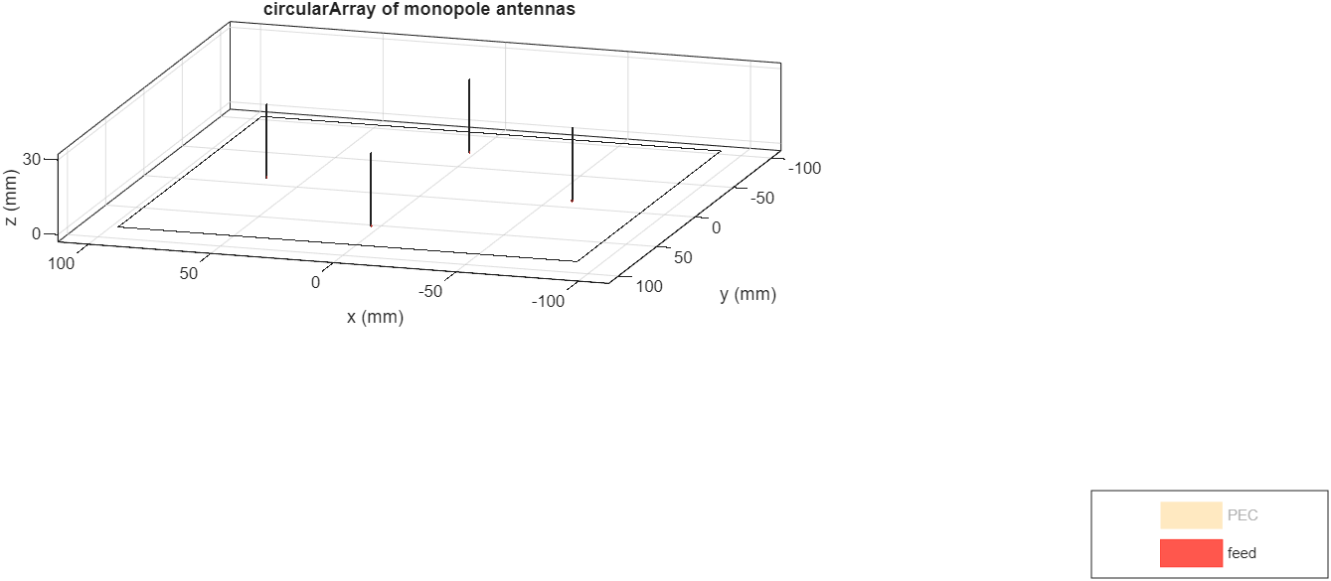
Fig 10. UCA Layout

The circular geometry provides rotational symmetry in the azimuth plane, enabling theoretically uniform performance for each azimuth quadrant of the array. The resulting radiation patterns in azimuth, elevation and 3D gain pattern are shown below in Fig 11.

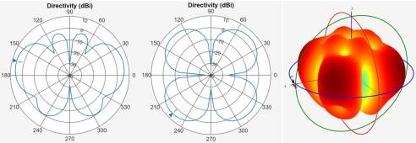
Fig 11. UCA Radiation Simulations Elevation Plane (Left), Azimuth Plane (Middle) & 3D Gain

Fig 11. above presents radiation pattern corresponding to M-element UCA configuration where M = 4. It was found that increasing the number of elements to M = 8 would produce a complete omnidirectional azimuth response. However, the implemented system was limited to 4 synchronized reciever channels due to the phase-coherence necessity, as well as the limited documentation and subsequent ability to synchronize between Zynq boards.

ULA Pattern
The second radiation pattern examined is the uniform linear array (ULA). A 4-element ULA is a commonly used configuration for DoA estimation because it provides sufficient spatial sampling of the incoming wave while keeping the array size and hardware complexity low. It is important to clarify that this work presents a study of a 4- element ULA with two similar but separate uses—one placed along the vertical axis, and the other placed along the horizontal axis—for elevation and azimuth respectively. However, regardless of the choice of orientation, the radiation pattern of the array stays consistent. Examine below which presents the radiation behavior of a 4-element ULA with antennas oriented along the axis of the array itself.

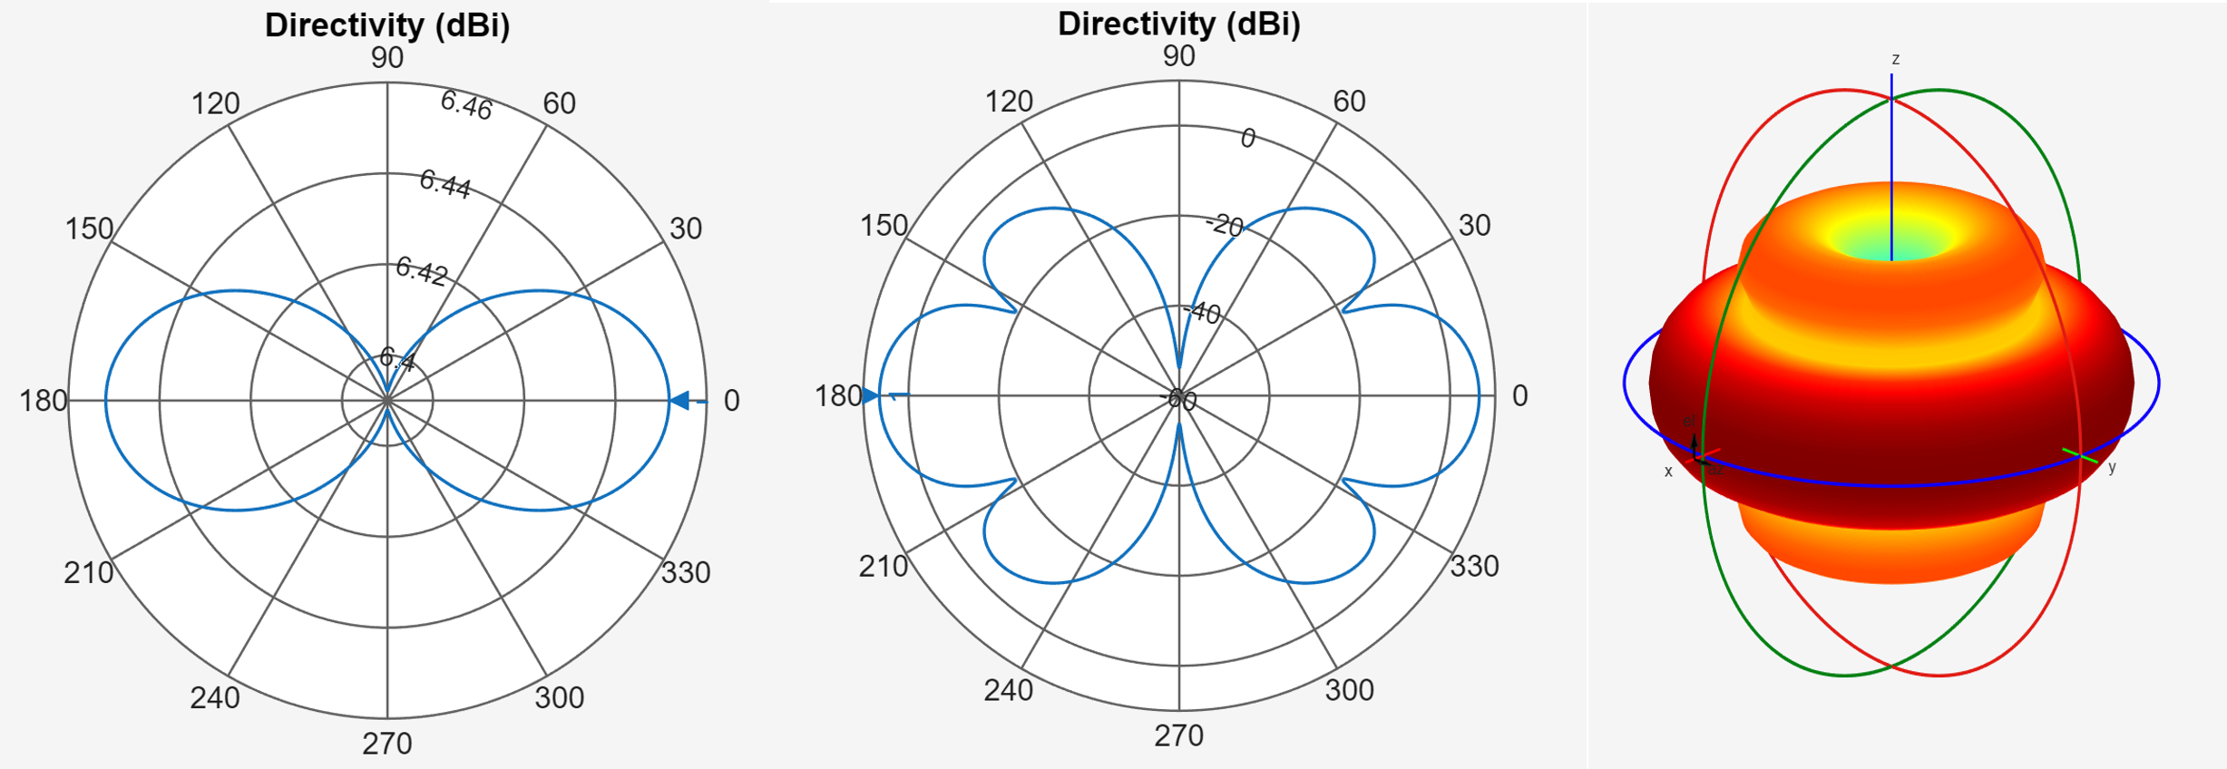
Fig 12. ULA Radiation Simulations with Elevation Plane (Left), Azimuth Plane (Middle) & 3D Radiation
As shown in Fig 12 above, the radiation pattern of the ULA produces very strong gain (6dB) in the broadside direction in reference to the axis of the array, producing a dominant main lobe along with several sidelobes and nulls. This array design has strong response to the front and back of the array but poor performace on the sides of the array.

LIVE DEMO TESTING SET-UP
Our live demonstration platform is a fully operational Direction-of-Arrival (DoA) estimation system designed for real-time azimuth, elevation, and range tracking of an RF source. The physical setup consists of two orthogonally mounted four-element antenna arrays that enable independent angle estimation in both spatial dimensions. The azimuth array may be configured as either a Uniform Linear Array (ULA) or Uniform Circular Array (UCA), while the elevation array is implemented as a vertical ULA. Each array is connected to its own phase-synchronized FMComms5 + Zynq software-defined radio (SDR) platform, ensuring coherent multi-channel acquisition across all eight receive elements.
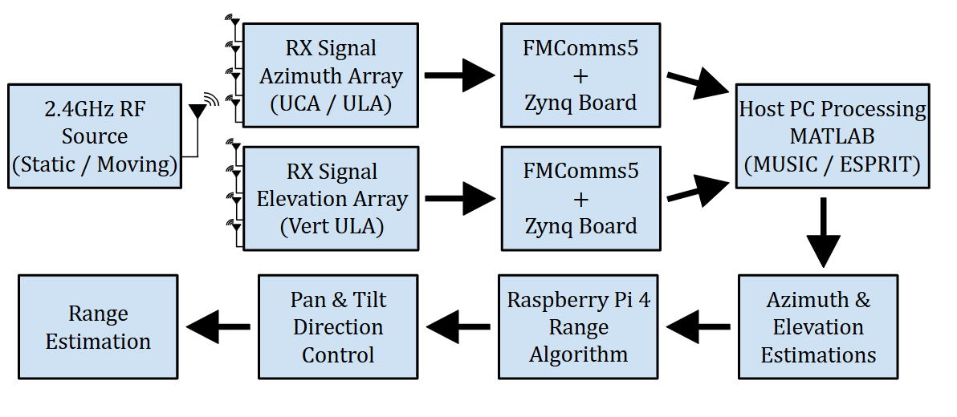
Fig 13. Real-Time Dual-Array Direction-of-Arrival Demo Architecture

The physical implementation directly mirrors the high-level architecture described above. The RF source consists of a USRP-2901 transceiver controlled by a Raspberry Pi 4, configured to transmit a continuous 2.4 GHz tone during testing. This compact transmission module provides a stable, low-profile, and easily repositioned source, allowing controlled static and dynamic movement throughout the test environment. The portability of the source enables repeatable angle verification and real-time tracking demonstrations without requiring large laboratory infrastructure.
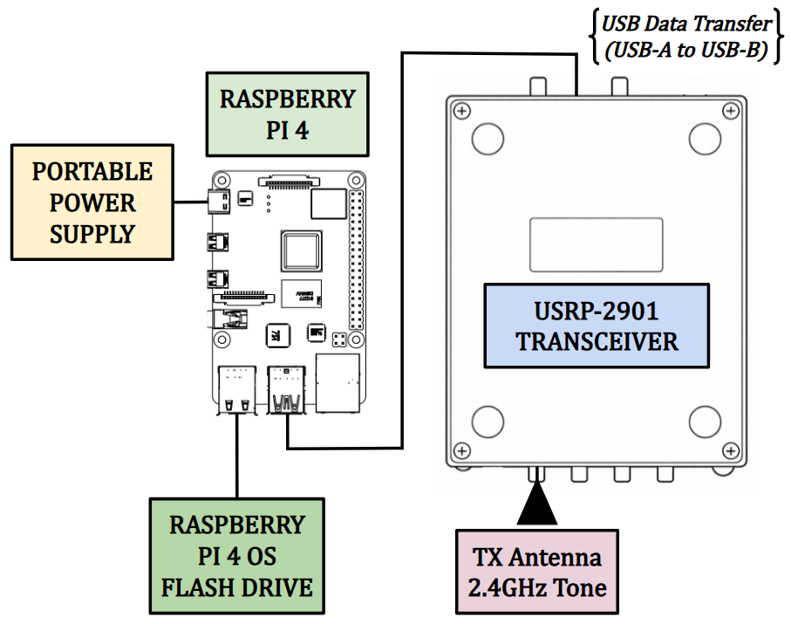
Fig 14. Live Demo Portable RF Source Testbed

RF Receiver Architecture

The most critical part of the hardware setup is the RF receiver system, which is responsible for capturing the emitted signal and computing the direction-of-arrival (DoA) estimation. The receiver architecture consists of three primary sections: the antenna array used to collect the incoming RF signal, the FMComms5/Zynq signal acquisition platform that performs RF downconversion and digitization, and a host PC where the DoA processing algorithms are executed in MATLAB. Two antenna configurations were implemented for testing: a UCA–ULA configuration for azimuth and elevation estimation, a dual ULA configuration used for comparison.
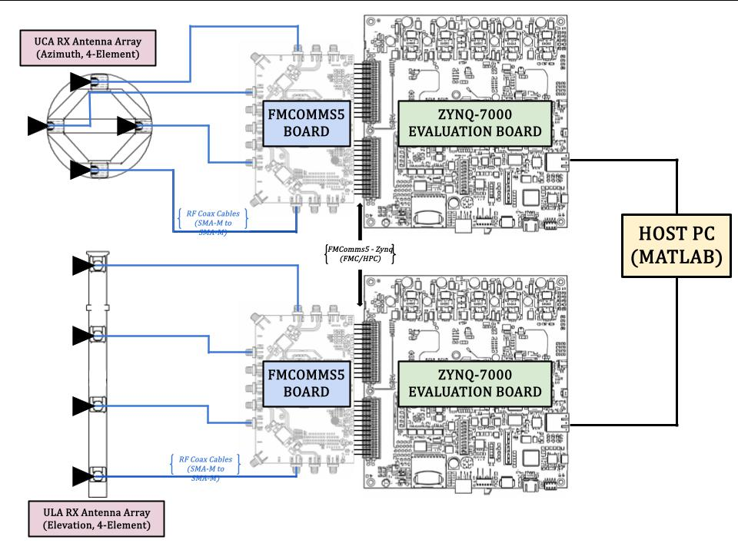
Fig 15. Live Demo RF Receiver Architecture (ULA/UCA)

Mechanical Range Architecture

After the azimuth and elevation estimations have been computed by the receiver system, the resulting directional information is transferred to the mechanical ranging subsystem to complete source localization. This subsystem consists of a Raspberry Pi controller, a pan–tilt servo platform, and a TF-02 LiDAR sensor used for distance measurement. The Raspberry Pi receives the estimated pointing angles from the host PC and commands the pan and tilt servos to orient the sensor toward the estimated direction of the RF source. Once aligned, the TF-02 LiDAR measures the distance to the target, allowing the system to estimate the full position of the signal source. The architecture of the mechanical range finding subsystem is shown in Fig 16.
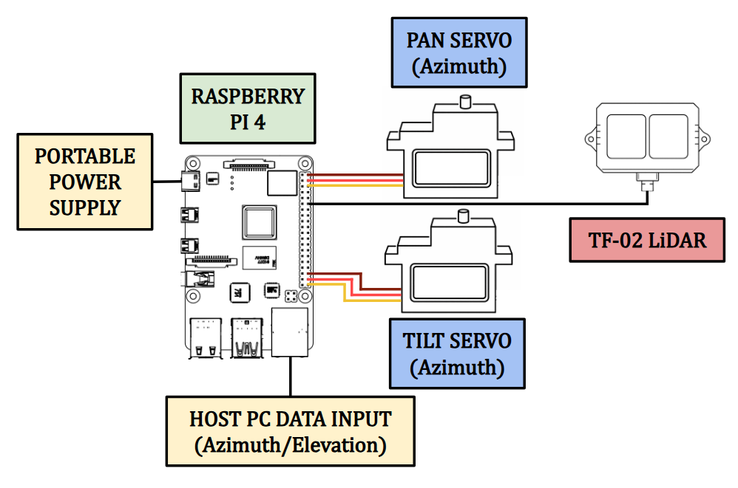
Fig 16. Live Demo Mechanical Range Finding Architecture

Complete Implementation

After completing the individual development of the signal source testbed, RF receiver subsystem, and LiDAR range-finding architecture, the final stage of the project is the integration of these components into a unified localization system. The figure below illustrates the complete system implementation, showing how each subsystem interacts to estimate the azimuth and elevation of the RF source before performing the final range measurement.

Starting with the signal source testbed shown in the top left of Fig 16, a continuous 2.4 GHz waveform is generated by the Raspberry Pi 4 and transmitted through the USRP-2901 software-defined radio. This signal propagates through the surrounding environment and acts as the RF source used for the localization experiments.

Once the emitted signal is captured by the antenna array, in either the ULA/UCA or ULA/ULA configuration, the received RF signals are routed to the FMComms5/Zynq signal acquisition platform. The platform simultaneously samples each antenna channel while preserving the phase relationships between elements, which are required for accurate direction-of-arrival estimation. The digitized data is then processed using the implemented MUSIC and ESPRIT algorithms to estimate the azimuth and elevation angles of the incoming signal.

After the azimuth and elevation estimations are completed, the calculated directional information is transferred to the Raspberry Pi 4 to control the pan/tilt servo motors that position the LiDAR sensor. The LiDAR is then aligned with the estimated direction of arrival and performs a range measurement toward the RF source. By combining the angular estimates from the RF receiver with the distance measurement from the LiDAR sensor, the system is able to determine the spatial location of the signal source within the test environment.

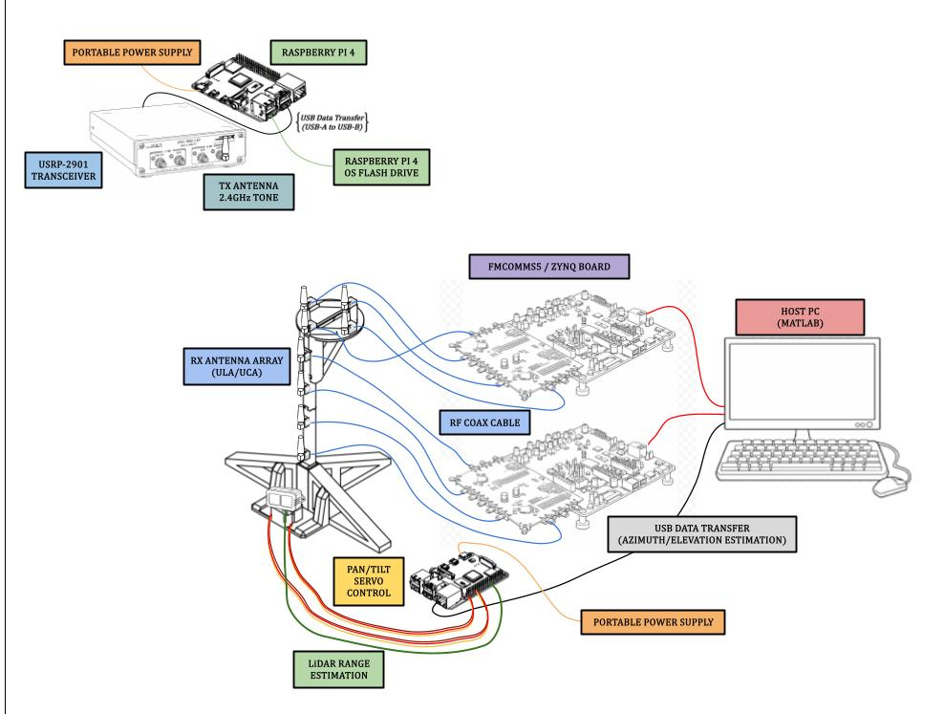
Fig 17. Live Demo Complete Implementation Visualization

Receiver Phase Synchronization
One of the most important factors in any DoA system is the phase synchronization of the receiver system. This system synchronization is achieved using the multi-chip synchronization capability of the FMComms5 boards, which contain dual AD9361 RF transceivers. This configuration ensures that the local oscillators, sampling clocks, and digital data paths across all receive channels start in a deterministic and phase-aligned state. As shown in the figure below, RF coaxial cables are connected from the TX channels to their respective RX channels during the phase synchronization process. A more detailed description of this procedure can be found in the appendices.
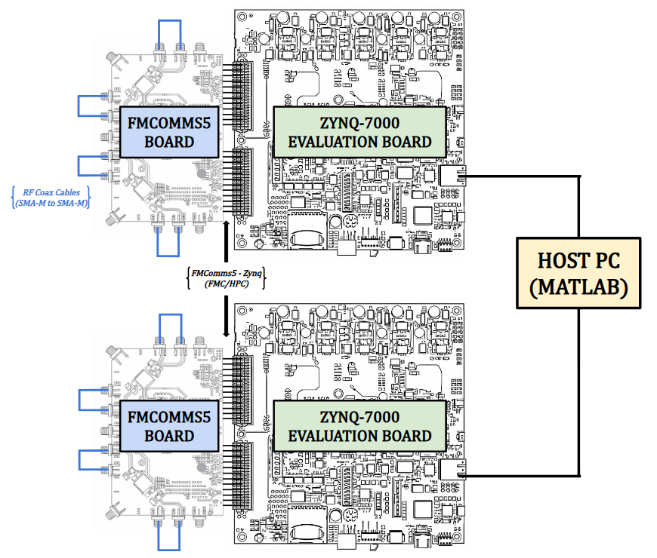
Fig 18. Receiver Phase Synchronization Set-Up

Testing Apparatus
The final phase of the demonstration setup focuses on accurately testing the system and collecting data for performance evaluation. Testing is conducted in two phases. The first phase evaluates the individual antenna array segments using both static and moving RF sources to verify that each array can independently estimate the appropriate angular component. The second phase integrates the arrays into either the ULA/UCA or ULA/ULA configuration to perform full azimuth and elevation DoA testing under both static and moving source conditions. Since the RF source must move in both azimuth and elevation in a controlled manner, a dedicated testing apparatus was developed. This apparatus allows the RF transmitter to move along a pivoting axis, maintaining a constant radial distance from the antenna arrays as it sweeps through different azimuth angles. A pulley-based vertical adjustment system is also incorporated to vary the elevation of the transmitter while maintaining the same horizontal radius. Known angular positions and vertical heights are measured and recorded so that when the transmitter is placed at a static location, the estimated DoA results can be directly compared to the known azimuth and elevation angles for accuracy verification.

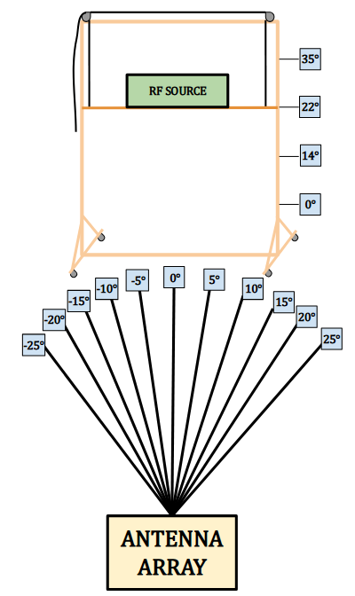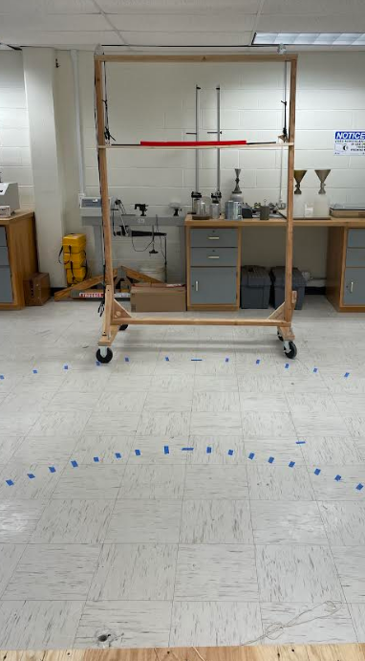
Fig 19. Live Demo Testing Apparatus

Using the apparatus described above, the proposed DoA system was experimentally tested to evaluate overall performance. During testing, two primary parameters were varied: the signal processing algorithm and the antenna array configuration. The MUSIC and ESPRIT algorithms were evaluated while operating with the ULA and UCA array configurations. Static testing was first conducted with the RF signal source positioned at known azimuth and elevation angles in order to establish a baseline for estimation accuracy. After static testing was completed, the same testing procedure was repeated with a moving RF source. During these moving tests, the signal source was only moved in the direction of interest; for example, during azimuth tests the elevation angle remained constant, and during elevation tests the azimuth angle remained fixed.

RESULTS AND OBSERVATIONS
Throughout this section, the gathered data for each hardware/software configuration will be presented and discussed in detail. The results compare the performance of the MUSIC and ESPRIT algorithms across the different antenna array configurations tested during the live demonstration. Each configuration is evaluated based on the accuracy and consistency of the estimated direction of arrival obtained during repeated trials. The moving source path is represented by either a linear or sinusoidal dashed line that accurately represents the path the source was moved.

Static Source Testing

The first moving source test evaluates the performance of the MUSIC algorithm using the UCA/ULA configuration. The test evaluates the RF source when placed at several fixed azimuth positions.. Figure 19 below presents the relationship between the true azimuth angle and the estimated azimuth for both outdoor and indoor environments, where the dashed line represents thethe true source position. Note: Fig. 19 below only depicts DoA using MUSIC—as ESPRIT has been shown to prove unsatisfactory for a 4-element UCA.
\ 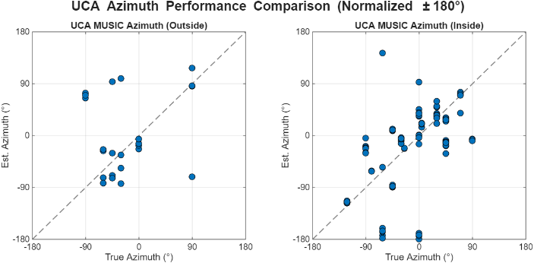
Fig 20. True vs Estimated DoA for UCA MUSIC Azimuth (Outside, Inside)

Referencing outside testing, it is apparent that most estimations are rather accurate, while few were not. This preliminarily indicates that further testing should be conducted to determine the cause of these outliers and how that they can be mitigated against. Regarding indoor testing, the algorithm is generally able to track the source direction with reasonable accuracy. However, some spread in the measurements is still present—even for repeated trials. These issues align with the aforementioned inherent behavior and capabilities of the 4-element UCA. caused by measurement noise and environmental effects.

The next set of static source testing evaluates the horizontal ULA performance while utilizing both the MUSIC and ESPRIT algorithms. These tests were conducted in the same manner as the UCA test, where the RF source was placed at several fixed azimuth positions and the estimated DoA produced by each algorithm was recorded. This test allows for a direct comparison of algorithm performance when operating under the same array geometry and environmental conditions. As shown in Fig 21, the estimated azimuth values are plotted against the true source position, with the dashed diagonal line representing the ideal case where the estimated DoA exactly matches the true angle. Regarding the left graph, it is clear that the performance of this configuration is not suitable for real implementation. Large errors are attributed to a poorly selected testing environment, where a large background reflected the source signal, subsquently creating an impactful multipathing effect. Regarding the right graph, it is clear that the ESPRIT algorithm handles the multipathing effect much better, minimizing errors to consistently less than 20°. Overall, the results highlight differences in estimation consistency between the MUSIC and ESPRIT algorithms when applied to the horizontal ULA configuration in an indoor environment.
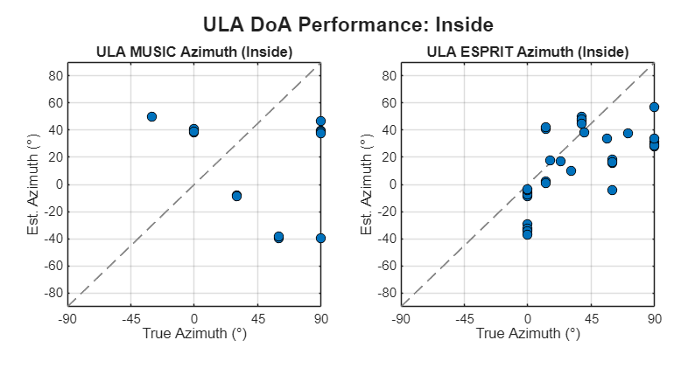
Fig 21. MUSIC/ESPRIT-ULA Static DoA Estimation

The final static test evaluates elevation estimation performance using the vertical ULA configuration while applying both the MUSIC and ESPRIT algorithms. Fig 22 below presents the estimated elevation angles compared to the true source elevation during indoor testing, where the dashed diagonal line represents the ideal case of perfect estimation. Both configurations performed poorly due to reflections from the indoor ceiling. The MUSIC results show greater spread in the estimated values, particularly at mid-range elevation angles, while the ESPRIT estimates contain less RMSE, however still exhibit varied estimations due to indoor multipath and measurement noise.

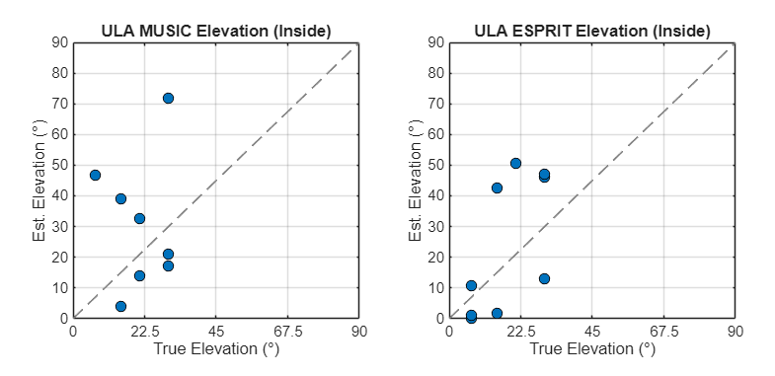
Fig 22. MUSIC/ESPRIT-ULA Static DoA Estimation

Moving Source Testing

The first moving source test evaluates the performance of the MUSIC algorithm using the UCA configuration. The test evaluates the system’s ability to track a dynamic RF signal source using the proposed DoA estimation methods. Two motion patterns were used during testing in order to observe system performance under different target trajectories. The signal source moves with respect to the origin at no more than 15cm/s. The resulting DoA estimates for both motion patterns are shown in the figures below.
\
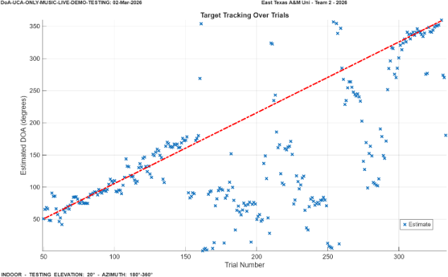
Fig 23. MUSIC-UCA Moving RF Source (Indoor)

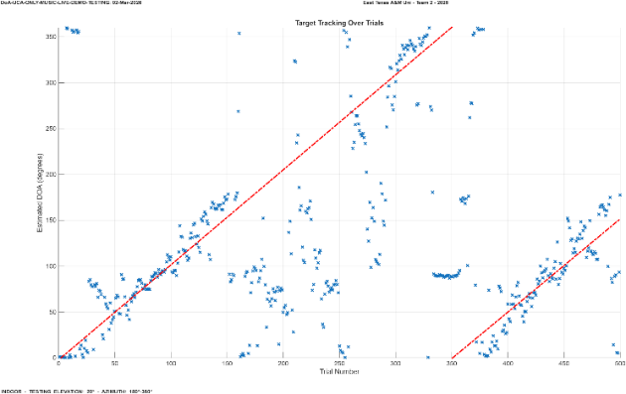
Fig 24. MUSIC-UCA Moving RF Source (Indoor)

Notice above in Fig 24 that from Trial 160-300 poor performance is observed. During this portion of the trials, a reflection from behind the source was affecting system performance. When this reflected signal, which arrives later due to the longer path, combines with the direct signal, it significantly impacts DoA estimation.

The second moving source test evaluates the performance of the ESPRIT algorithm while using the ULA configuration. The resulting DoA estimates for both motion patterns are shown in Fig 27 and Fig 28 below.
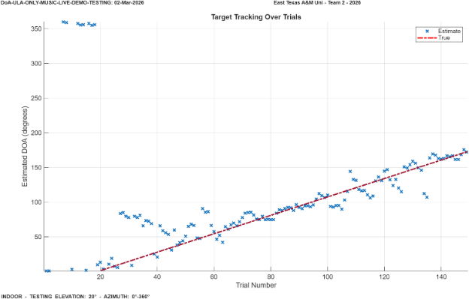
Fig 25. ESPRIT-ULA Moving RF Source (Indoor)
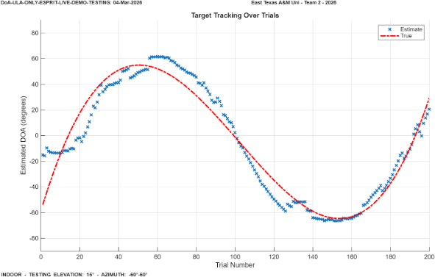
Fig 26. ESPRIT-ULA Moving RF Source (Indoor)

The final moving source tests evaluate the performance of the vertical ULA configuration. During these tests, the RF source was moved along the same general paths used in the previous experiments. The first test consisted of a steady sweep where the elevation angle of the source was varied while the azimuth remained constant. Following this, a second test was performed in which the source was moved in a back-and-forth motion across the elevation range in order to evaluate the system’s ability to track changes in elevation direction. The resulting DoA estimates for both motion patterns are shown in the figures below.

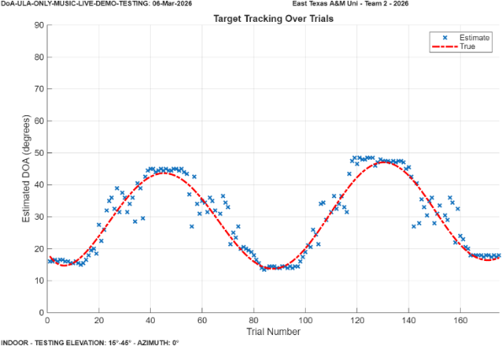
Fig 27. MUSIC-ULA Moving RF Source (Indoor)

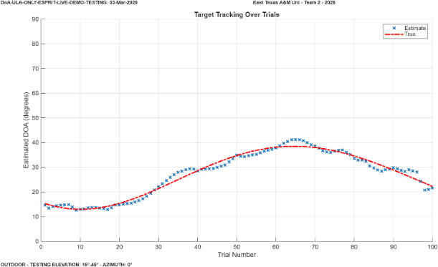
Fig 28. ESPRIT-ULA Moving RF Source (Indoor)
Fig 27. and Fig 28. show promising results that indicate great ability to track an object moving at <15cm/s.

CONCLUSION
Several important observations were made throughout the simulation and experimental evaluation of the proposed RF localization system. First, the geometry of the antenna array was found to have the greatest influence on direction-of-arrival estimation accuracy and stability. Configurations that preserved a uniform linear structure in both spatial dimensions produced the most stable covariance estimation and the lowest estimation error. In particular, the dual-ULA configuration demonstrated more consistent performance than the ULA/UCA configuration because it maintained the shift-invariant structure required by subspace-based algorithms. While both MUSIC and ESPRIT were evaluated, the ESPRIT algorithm showed strong performance even with fewer snapshots, indicating improved computational efficiency and making it well suited for real-time implementation. In contrast, the MUSIC algorithm required larger snapshot counts in order to stabilize the covariance matrix and reliably separate the signal and noise subspaces.
Additional observations were made regarding the physical antenna configurations used in the system. The implemented four-element UCA did not produce a fully omnidirectional azimuth response, and simulation results indicated that increasing the element count to eight would significantly improve isotropy and angular resolution. However, the system was constrained to four synchronized receiver channels due to hardware limitations and the requirement for phase-coherent acquisition. During experimental testing, environmental multipath effects were identified as the dominant source of estimation error. Indoor reflections from surrounding surfaces such as walls and ceilings introduced delayed signal paths that degraded DoA estimation accuracy. This effect was particularly noticeable during elevation testing using the vertical ULA, where reflections from the ceiling caused increased variability in the estimated angles. In several cases, the ESPRIT algorithm demonstrated improved robustness to multipath compared to MUSIC when operating on the ULA configuration.
The experimental system was also capable of tracking a moving RF source under controlled conditions. Tests demonstrated that the system could successfully estimate and track the direction of a source moving at speeds below approximately 15 cm/s, indicating that the architecture is capable of supporting slow dynamic tracking scenarios. Reliable operation required accurate phase synchronization across all SDR receiver channels, as deterministic phase alignment between antenna elements is essential for maintaining the spatial phase relationships used by DoA algorithms. This synchronization was achieved using the multi-chip synchronization capabilities of the FMComms5 platform.
From a system-level perspective, the results suggest several key conclusions. Overall localization performance was governed primarily by array geometry rather than algorithm selection, particularly when using subspace-based estimation methods. Uniform linear array structures provide a favorable framework for DoA estimation because they preserve the mathematical assumptions required by algorithms such as ESPRIT. The results also demonstrate that real-time DoA estimation is feasible using synchronized SDR hardware when proper phase calibration and covariance estimation techniques are employed. However, multipath propagation remains the dominant practical limitation for indoor RF localization systems. Finally, the integration of LiDAR with RF-based direction estimation proved to be an effective hybrid sensing approach. By combining RF-derived azimuth and elevation estimates with LiDAR range measurements, the system was able to determine the full spatial position of the RF source in spherical coordinates. Future improvements to the system would likely involve increasing the number of antenna elements to enhance spatial resolution and developing techniques to improve robustness against multipath interference in complex environments.

ACKNOWLEDGEMENTS
X

References
- Codău, C.; Buta, R.-C.; Păstrăv, A.; Dolea, P.; Palade, T.; Puschita, E. Experimental Evaluation of an SDR-Based UAV Localization System. Sensors 2024, 24, 2789. https://doi.org/10.3390/s24092789
- H. -C. Chen, T. -H. Lin, H. T. Kung, C. -K. Lin and Y. Gwon, "Determining RF angle of arrival using COTS antenna arrays: A field evaluation," MILCOM 2012 - 2012 IEEE Military Communications Conference, Orlando, FL, USA, 2012, pp. 1-6,
doi: 10.1109/MILCOM.2012.6415851
- O. A. Oumar, M. F. Siyau and T. P. Sattar, "Comparison between MUSIC and ESPRIT direction of arrival estimation algorithms for wireless communication systems," The First International Conference on Future Generation Communication Technologies, London, UK, 2012, pp. 99-103, doi: 10.1109/FGCT.2012.64765631
- https://wiki.analog.com/_media/resources/tools-software/linux-software/doa_whitepaper.pdf
- M. A. ihedrane, A. E. FAdl, and S. Bri, “Direction of Arrival Using 2-D Matrix Pencil Method,” Advances in Science, Technology and Engineering Systems Journal, vol. 4, no. 5, pp. 341–342, 2019, doi: https://doi.org/10.25046/aj040544.
- ‌Cristian Codău, R.-C. Buta, A. Păstrăv, P. Dolea, Tudor Palade, and E. Puschita, “Experimental Evaluation of an SDR-Based UAV Localization System,” Sensors, vol. 24, no. 9, pp. 2789–2789, Apr. 2024, doi: https://doi.org/10.3390/s24092789.
- K. A. Jabr, H. M. Kwon and N. Tayem, "Modified UCA-ESPRIT for Estimating DOA of Coherent Signals using One Snapshot," VTC Spring 2008 - IEEE Vehicular Technology Conference, Marina Bay, Singapore, 2008, pp. 290-293, doi: https://doi.org/10.1109/VETECS.2008.72.
- xxx

